1. **General Research Question:** What approaches would improve biological image segmentation using neural networks?

**Focused Research Question:** To what extent would a pixelwise convolutional neural net classifier improve overall accuracy of biological image segmentation?

**Keywords:** “Medical Image Segmentation”, “Pixelwise Classification”, “Convolutional Neural Network”, “Semantic Segmentation”

**APA Citations:**

Turaga, S. C., Murray, J. F., Jain, V., Roth, F., Helmstaedter, M., Briggman, K., . . . Seung, H. S. (2010). Convolutional Networks Can Learn to Generate Affinity Graphs for Image Segmentation. Neural Computation, 22(2), 511-538. doi:10.1162/neco.2009.10-08-881

Noh, H., Hong, S., & Han, B. (2015). Learning Deconvolution Network for Semantic Segmentation. 2015 IEEE International Conference on Computer Vision (ICCV). doi:10.1109/iccv.2015.178

1. Advisor and Second reader pending approval from Dr. Yongsoo Kim at Penn State College of Medicine. His role in the project, along with a solidified focused research question, will be confirmed when he replies to my email, which should be before our next class meeting.

Below is an example of a mask generated from a microscope scan that I created using a neural net this summer, using Dr. Kim’s data (attempting to identify the small, ovular cell structures only):

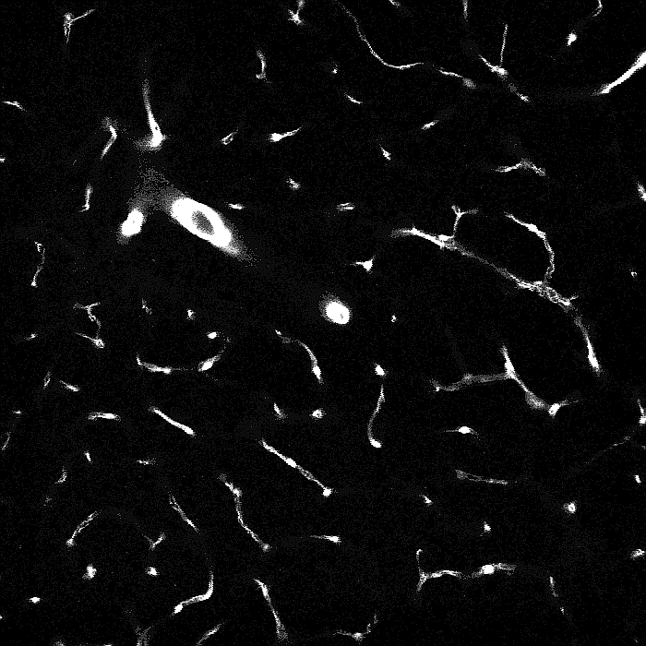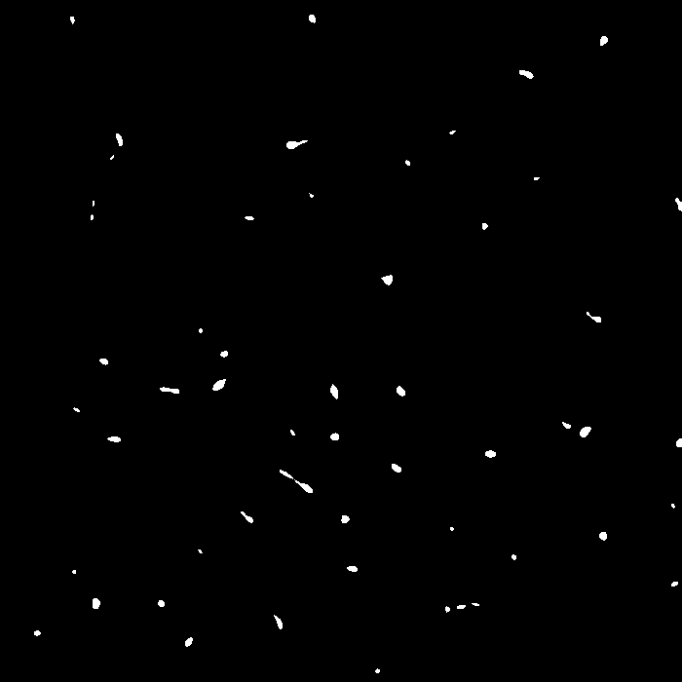

Two previous papers using CNNS from Dr. Kim:

<https://www.frontiersin.org/articles/10.3389/fncir.2016.00003/full>

https://www.cell.com/cell-reports/fulltext/S2211-1247(14)01043-2?_returnURL=https%3A%2F%2Flinkinghub.elsevier.com%2Fretrieve%2Fpii%2FS2211124714010432%3Fshowall%3Dtrue